Low Level Design(UPDATE PRODUCT MODULE)

Project Code | Team1
Project Name | E-Commerce Online Shopping Solution

Prepared/Modified by | Role | Date of Preparation
Shrikant Sutar | Software Engineer | 16/12/2013
Reviewed by | Role | Date of Review
Mrunalee Kothari | Software Engineer | 17/12/2013
Approved by | Role | Date of Approval
Uma M Ponniamman | Training Manager
Circulation List | amit.agarwal@igate.com, mrunalee.kothari@igate.com, keerthi.parthasarathy@igate.com, nidhi.shetty@igate.com, nikeeta.menon@igate.com, shrikant.sutar@igate.com, bhagyashree.vedpathak@igate.com | Version Number of the template:1.0
Version Number | 1.3

Table of Contents

1. Description Of The Unit 3
2. References 4
3. Dependencies / Assumptions 5
4. Class Diagrams 6
5. Sequence Diagrams 7
6. Design Components 8
6.1 List Of UI Components 8
6.2 List Of Design Classes 8
7. Re-Usable Routines/Components 9
8. Messages 10
9. Configuration Files 11
10. Crud Matrix Table 12
11. Data Mapping Matrix 13
12. Action Flow Matrix 14
13. Stored Procedures 15
14. Program Specification / Pseudo Code 16
REVISION HISTORY OF THE WORK PRODUCT 17

Description Of The Unit

The Update module is basically used by the administrator of the system, to update the existing product. It requires a pre-requisite that the administrator should be logged into the system.

On clicking the update button on the admin home page, the admin will be redirected to the actual home page where he selects a product to be updated. Once the product is chosen for updating, previously existing details about that product which are brought from the database are displayed in the text fields. The admin can then modify desired fields and then update the changes in the database. Modified fields are first validated, if valid the details are updated into the database and the admin is redirected to his home page or else if the entered details are invalid an appropriate error message is displayed.

References

Reference | Description
Repository reference | https://IGTEBLRSVNTNG.igatecorp.com/svn/oct3_Team1
Class Diagram | /Project Documents/Design Documents/HLD/Class Diagrams
URS | /Project Documents/Requirements/Case Study/Ecommerce-grp1 and grp3.doc
UTP | Project Documents/Test Plan/UTP/Test Cases/ UpdateProduct/ UTP_UpdateProductModule.xls
DB Design | /Project Documents/Design Documents/HLD/DB Design/E-Commerce_GROUP_DBDESIGN.xls

Dependencies / Assumptions

Dependencies:
Update module depends on the Login module in such a way that, the admin is able to update a product only when he is logged in.

Class Diagrams

Class Diagram

Sequence Diagrams

Sequence Diagram
NA

Design Components

List Of UI Components
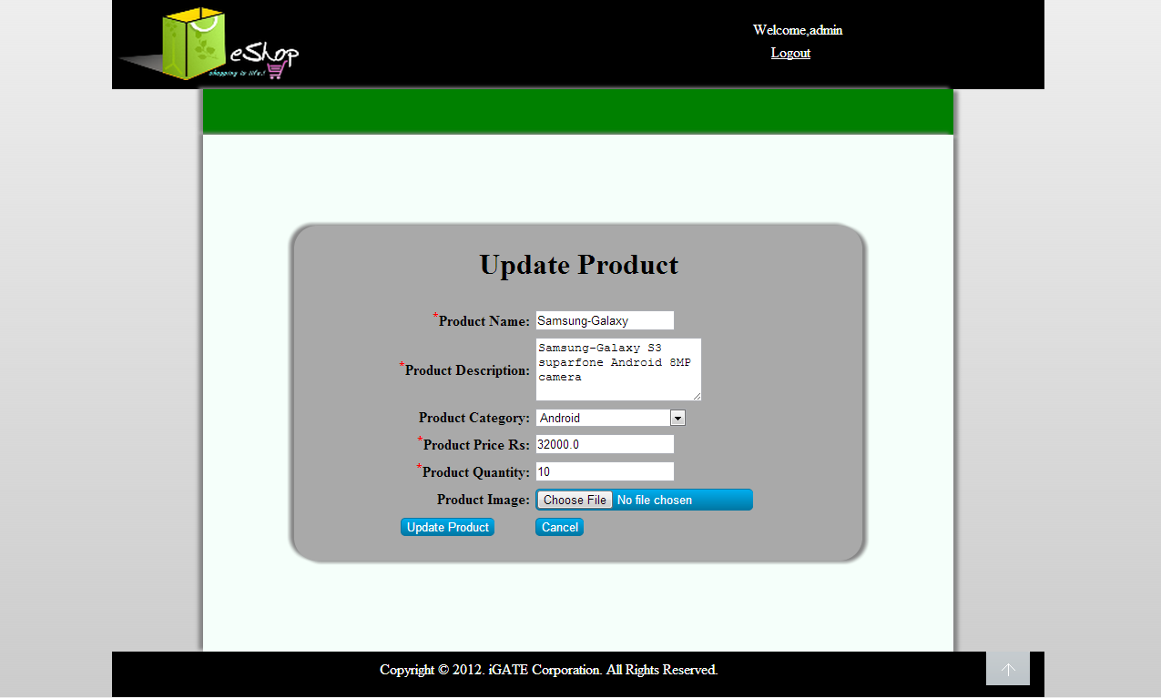

List Of Design Classes
Sr. No. | LLD Name | Class Name | Method Name | Method Description
1 | Update Module | Product,  ProductImage | Appropriate getters and setters methods | Getters retrieve the property values and setters set the property values
2 | Update Module | EshopController | proceedToUpdate (Model model):String  showUpdateForm  (String productId,Model model)  String  updateProduct  (String operation,String filename,Product product,BindingResult result,Model model):String | Sets the model attribute.  Calls getProductDetails (productId) of EcommerceBOImpl class. It basically fetches details of existing product as product object and sets it into session , then it redirects to update page else in case of exception redirects to error page with appropriate error message.  Calls updateProduct(Product,  String) of EshopBOImpl class. If it returns true then it redirects to update page with a span message else it redirects to error page with appropriate error message.
3 | Update Module | EshopBOImpl | getProductDetails(String):Product  getSubCategoryList():List  updateProduct(Product,String):int | Calls getProductDetails  (String) of EshopDaoImpl class and returns the result to controller.  Calls getSubCategoryList():List  of EshopDaoImpl class and returns the result to controller.  Calls updateProduct(Product) of EshopDaoImpl class if the product image file is valid and returns the result to controller.

4 | Update Module | EshopDAOImpl | getProductDetails(String):Product  getSubCategoryList():List  updateProduct(Product):int | Gets the details of the desired product depending upon the product ID from database and returns Boolean result to EshopBOImpl .  Gets the list of sub-categories from database and returns it to EshopBOImpl .  Update the desired product and its image into the database and returns boolean result to EshopBOImpl .

Re-Usable Routines/Components

Re-Usable Routines/Components

- CSS files
- Javascript files
- DataAccessException class
- Database properties files
- Logger properties files

Messages

#. | Type | Message Text
M1 | Error | Enter a valid product name
M2 | Error | Enter a valid product description
M3 | Error | Enter a valid product price
M4 | Error | Enter a valid product quantity
M5 | Error | Choose an appropriate file
M6 | Error | Product name should not exceed 50 characters
M7 | Error | Description should not exceed 100 characters

Configuration Files

File Name | Path | Description
oracle.properties | /Development/Source | To configure database connection.
Web.xml | /Development/Source | To configure the bean properties.
Dispatcher-servlet.xml | /Development/Source | To configure the request mapping and view resolver.
Eshop_logger.properties | /Development/Source | To configure the logger.
Eshop_error.properties | /Development/Source | To configure error messages.

Crud Matrix Table

# | Table Name | Create | Read | Update | Delete
1 | Product | N | Y | Y | N
2 | ProductImage | N | Y | Y | N
3 | Sub_category | N | Y | N | N

Data Mapping Matrix

Sr. No. | Screen Label | Field Source | Field Type | Data Type | Max Length | Data Flow | Mandatory
1 | Product Name | NA | Label | NA | NA | UI | NA
2 | txtProductName | Product.Product_Name | TextBox | Varchar2 | 50 | D→UI  UI→D | Yes
3 | Product Description | NA | Label | NA | NA | UI | NA
4 | txtProductDescription | Product.Product_Description | TextBox | Varchar2 | 50 | D→UI  UI→D | Yes
5 | Product Sub-Category | NA | Label | NA | NA | UI | NA
6 | optProductSubCategory | Product.Product_Sub_Category | ListBox | Varchar2 | NA | D→UI  UI→D | Yes
7 | Product Price | NA | Label | NA | NA | UI | NA
8 | txtProductPrice | Product.Product_Price | TextBox | Number | NA | D→UI  UI→D | Yes
9 | Product Quantity | NA | Label | NA | NA | UI | NA
10 | txtProductQuantity | Product.Quantity | TextBox | Number | NA | D→UI  UI→D | Yes
11 | Product Image | NA | Label | NA | NA | UI | NA
12 | fileProductImage | ProductImage.Image | File | Varchar2 | 50 | D→UI  UI→D | Yes
13 | Update Product | NA | Button | NA | NA | UI | NA
14 | Go to Home Page | NA | Button | NA | NA | UI | NA

Legend
D → UI (Database to User Interface)
UI → D (User Interface to Database)
UI (User Interface Only)

Action Flow Matrix

Sr. No. | Action | Description | Process
1 | On click of Update Button on admin home page | Admin is navigated to home screen | When admin clicks on this button he/she is navigated to the home screen where he/she can select the product to be updated.
2 | On click of Update button for a particular product on home screen | Admin is navigated to product description page | When admin clicks on update button if one particular product he is navigated to description page where he can modify desired fields related to that product.
3 | On click of Update Product button in Product Description page. | Admin is notified about the updation of product | On clicking update product button, the modified values of the product attributes are updated into the database.
4 | On click of Go to Home Page Button | Control goes back to admin home page | When Go to Home Page button is pressed, the admin is navigated to the admin home page

Stored Procedures

# | Stored Procedure Name  (with Description) | Input/Out Parameters | Type | Size
1. | N/A | N/A | N/A | N/A

Program Specification / Pseudo Code

<ACTION: UPDATE_CLICK >

Pseudo Code:
- Client Side Scripting:
None

- Server Side Scripting:
BEGIN
Call proceedToUpdate (Model model) in Controller class
BEGIN
Call getProductDetailsList() from EshopBOInterface of service layer
BEGIN
Call getProductDetailsList() in EshopDAOInterface of dao layer.
BEGIN
Create query for retrieving product details list from Product table
Return Product List
END
Return Product List to service layer.
END
Return Product List to presentation layer.
END
Navigate to home screen page
END

<ACTION: UPDATE_CLICK >

Pseudo Code:
1. Client Side Scripting:
None

2. Server Side Scripting:
BEGIN
Call showUpdateForm(Product product,ProductImage productImage,BindingResult result,Model model) in Controller class in presentation layer.

BEGIN
Call getProductDetails(String) in EshopBOImpl class in Service Layer
Call getSubCategoryList() in EshopBOImpl class in Service Layer

BEGIN
Call getProductDetails(String) in
EcommerceDaoImpl class in Data Access Layer

Call getSubCategoryList () in
EcommerceDaoImpl class in Data Access Layer

BEGIN
Create query for retrieving product details from Product and Product_Image table .
Return Product

Create query for retrieving Sub-Category list from Product table
Return subCategoryList

END
Return Product to Service Layer
Return subCategoryList to Service Layer
END
Return Product to Presentation Layer
Return subCategoryList to Presentation Layer
END
Navigate to home screen page
END

14. 2 <ACTION: UPDATE_PRODUCT_CLICK>

Pseudo Code:

- Client Side Scripting:

IF productName isEmpty
Print Error Message M1
IF productDescription isEmpty
Print Error Message M1

IF productPrice isEmpty
Print Error Message M1
IF productQuantity isEmpty
Print Error Message M1
IF productImage isEmpty
Print Error Message M5

IF invalid productName
Print Error Message M1
IF invalid productPrice
Print Error Message M2
IF invalid productQuantity
Print Error Message M3
IF invalid productImage
Print Error Message M5

- Server Side Scripting:
BEGIN
Call updateProduct(Product product,ProductImage productImage,BindingResult result,Model model):String in Controller class in Presentation Layer

BEGIN
Call updateProduct(Product):Integer in EshopBOImpl class in Service Layer
BEGIN
Call updateProduct(Product):Integer in EshopDAOImpl class in Data Access Layer.
BEGIN
Create query for updating product details into Product and ProductImage table
Return integer
END
Return integer value to Service Layer
END
Return integer to Presentation Layer
END
IF integer value is not zero, show appropriate success message
Else navigate to error page with proper error message
END

REVISION HISTORY OF THE WORK PRODUCT

# | Date | Version # | Section Changed | Details of changes made | Approved By
1 | 16/12/2013 | 1.0 | LLD prepared | NA | Uma M Ponniamman
2 | 17/12/2013 | 1.1 | List of Design classes(6.2) | Name of the controller is modified to EshopController | Uma M Ponniamman
3 | 18/12/2013 | 1.2 | 6.2,10 | Added a method getSubCategoryList() | Uma M Ponniamman
4 | 24/12/2013 | 1.3 | Configuration files,UI Components | Paths of the configuration files is updated and UI components(Screen Shots) added. | Uma M Ponniamman

